

**Mrs. Hudak’s 2nd Grade News**

**Phone: 216-642-5870 x1410 E-mail: ahudak@independence.k12.oh.us**

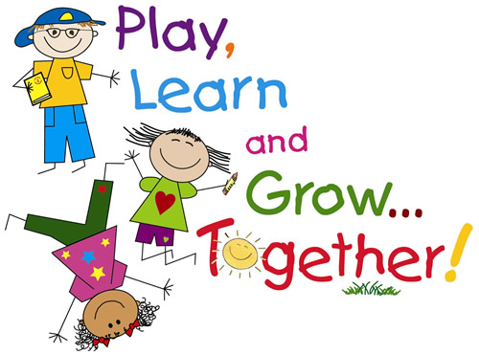





## Additional Information

### September 9, 2019

**Math:**

We will be adding with doubles (ex/ 4+4), near doubles (ex/ 4+5) and making a group of 10. We will also add 3 numbers and do some problem solving. Please be sure to check over the homework assignment with your child, **initial the bottom of the paper**, and return the homework to school the following day.

**Language Arts:**

In Reading we will read the story “Little Flap Learns to Fly”. We will be learning about key details in fantasy stories.

Vocabulary: actions, afraid, depend, nervously, peered, perfectly, rescue and secret. The students will need to know what these words mean and be able to match the word with the definition

Grammar: We will learn about statement and question sentences. We will also learn about the plural nouns with –s and –es.

In Fundations we will review digraphs and blends. We will practice tapping words. Please remember, the test will have words that go along with the skill we learned this week. The best way to practice is to do the daily homework as assigned.

Please remember to refer to your Fundations packet for your nightly homework.

The students have been doing a great job turning in their homework on time. Please initial the bottom of the paper too so that I know you have seen it and checked for correct answers.

Your child will be bringing home a poem to read to you on Friday that we practiced throughout the week. Please sign the Lucky Reader sheet and return to school on Monday. This will be a weekly assignment. Thank you for your help!!

Wednesday, September 11th is National Anthem Day. Please have your child wear red, white and blue that day!

Henry

**Social Studies:**

Students will learn about landforms – land and water.

Vocabulary Words: landform, island, peninsula and gulf