

**Mrs. Hudak’s 2nd Grade News**

**Phone: 216-642-5870 x1410 E-mail: ahudak@independence.k12.oh.us**

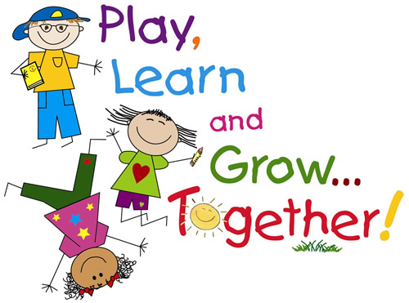





## Additional Information

### September 16, 2019

**Math:**

We will be focusing on subtraction this week. We will subtract all and 0’s. We will also use doubles.

We are beginning our weekly timed tests. I am sending home a letter on Monday about this. Please be sure to practice facts nightly using our POP paper.

**Language Arts:**

In Reading we will read the story “Maria Celebrates Brazil”. We will be learning about fiction and realistic fiction stories. We will identify the characters, setting and events in a story.

Vocabulary: aside, culture, fair, invited, language, plead, scurries, share

Grammar: We will learn about Commands and exclamation sentences. We will also learn about the suffixes of –s and –es and identify the root word.

In Fundations we will talk about the /k/ sound – when to use c, k, or ck. We will review what closed syllables are and review blends.

Independence Primary School will take part in the week long spirit activities leading up to the big homecoming game Friday night, September 20th at Independence High School.  Please wear the below attire each day for spirit week:

Monday, September 16th - Browns Day (Browns play Monday night)

Tuesday, September 17th - Beach Day (Favorite beach attire)

Wednesday, September 18th - Character Day (Favorite movie/TV character)

Thursday, September 19th - College Team Day (Favorite college)

Friday, September 20th - IPS Spirit Day (extreme blue and gold)

**We will be doing our Reading and Math Star testing this week. There is nothing to study for, just reinforce to your child to do their best. These scores will help decide which students need supplemental help or enrichment.**

Please remember that September 19th is Walk to School Day.

**Social Studies:**

Students will learn continue to about landforms and how to read a landform map.

Vocabulary Words: landform peninsula, island, gulf

Max